UNIT-II
PROCESS MODELS
- Process Models help in the software development
- They Guide the software team through a set of framework activities
- Process Models may be linear, incremental or evolutionary
THE WATERFALL MODEL
- Used when requirements are well understood in the beginning
- Also called classic life cycle model.
- A systematic, sequential approach to Software development
- Begins with customer specification of Requirements and progresses through planning, modeling, construction and deployment
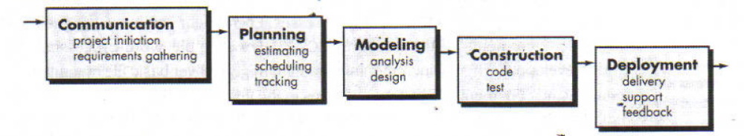
Disadvantages:
- Real projects rarely follow the sequential flow since they are always iterative
- The model requires requirements to be explicitly spelled out in the beginning, which is often difficult
- A working model is not available until late in the project time span

THE INCREMENTAL PROCESS MODEL
- Linear sequential model is not suited for projects which are iterative in nature
- Incremental model suits such projects
- Used when initial requirements are reasonably well-defined and compelling need to provide limited functionality to users quickly and then refine and expand on that functionality in later releases
It combines elements of waterfall model in an iterative fashion.
The incremental model applies linear sequences in a staggered ashion as calendar time progresses.Each linear sequence provides deliverable increments of software.For ex word processing sotware developed sing incremental paradigm might deliver basic file management,editing,and document production functions in 1st increment ;more sophisticated editing and document production capabilities in 2nd increment;spelling and grammar checking in 3rd increment; etc
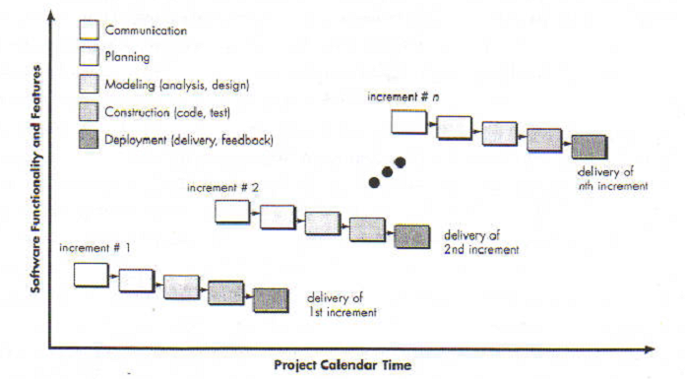

- 1st increment constitutes Core product
- Basic requirements are addressed
- Core product undergoes detailed evaluation by the customer
As a result, plan is developed for the next increment Plan addresses the modification of core product to better meet the needs of customer
- Process is repeated until the complete product is produced
The incremental process model unlike prototyping and other evolutionary approaches,is iterative in nature.But unlike prototyping,the incremental model focuses on delivery of an operational product with each increment.
This model is particularly useul when staffing is unavailable for a complete implementation by business deadline that has been established for the project.
THE RAD MODEL
(Rapid Application Development
- An incremental software process model
- Having a short development cycle
- High-speed adoption of the waterfall model using a component based construction approach
- Creates a fully functional system within a very short span time of 60 to 90 days
- Multiple software teams work in parallel on different functions
- Modeling encompasses three major phases: Business modeling, Data modeling and process modeling
- Construction uses reusable components, automatic code generation and testing
- Problems in RAD
- Requires a number of RAD teams
- Requires commitment from both developer and customer for rapid-fire completion of activities otherwise it fails
- If system cannot be modularized properly project will fail.
- Not suited when technical risks are high
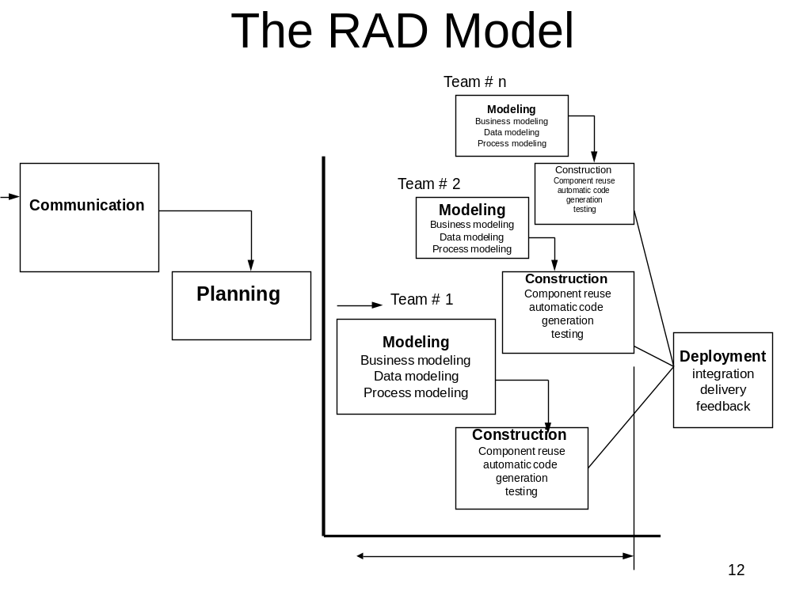EVOLUTIONARY PROCESS MODEL
- Software evolves over a period of time
- Business and product requirements often change as development proceeds making a straight-line path to an end product unrealistic
- Evolutionary models are iterative and as such are applicable to modern day applications
- Types of evolutionary models
  - Prototyping
  - Spiral model
  - Concurrent development model
PROTOTYPING
- Mock up or model( throw away version) of a software product
- Used when customer defines a set of objective but does not identify input,output,or processing requirements
- Developer is not sure of:
  - efficiency of an algorithm
  - adaptability of an operating system
  - human/machine interaction
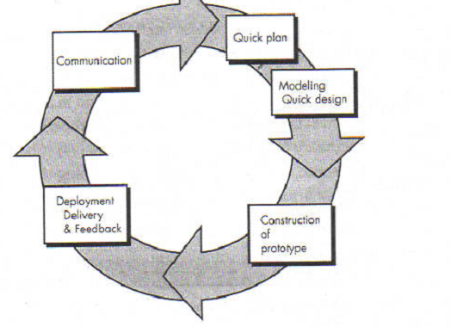
- Begins with requirement gathering
- Identify whatever requirements are known
- Outline areas where further definition is mandatory
- A quick design occur
- Quick design leads to the construction of prototype
- Prototype is evaluated by the customer
- Requirements are refined
- Prototype is turned to satisfy the needs of customer,while at the same time enabling developer to better understand hat needs to be done.
- Ideally prototype serves as a mechanism for identifying software requirements.
Disadvantages:
- In a rush to get it working, overall software quality or long term maintainability are generally overlooked
- The developer often makes implementation compromises in order to get a prototype working quickly.An inappropriate OS or PL may be used simply because it is available and known;an inefficient algorithm may be implemented simply to demonstrate capability.After a time,developer may become comfortable with these choices and forget all the reasons why they were inappropriate.
Spiral model
- This is a model proposed by boehm it is an evolutionary model which combines the best feature of the classical life cycle and the iterative nature of prototype model
- Include new element : Risk element
- Starts in middle and continually visits the basic tasks of communication, planning,modeling,construction and deployment
- Using spiral model,software is developed in a series of evoltionary releases.During early iterations,the release might be a model or prototype.During later iterations increasinly more complete versions of engineered system are produced
- Realistic approach to the development of large scale system and software
- Unlike other process models that end when software is delivered,the spiral model can be adapted to apply through out the life of computer software.Therefore the first circuit around the spiral represent a “concept development project” which starts at the core of the spiral and contines for multiple iterations until concept development is complete.If the concept is to be developed into an actual product,process proceeds outward on the spiral and a “new product development project “commences.The new product will evolve through a number of iterations around the spiral.Later,a circuit around spiral might be used to represent a “product enhancement project”.The spiral remains operative until the software is retired.
- It is difficult to convince customers that the evolutionary approach is controllable.

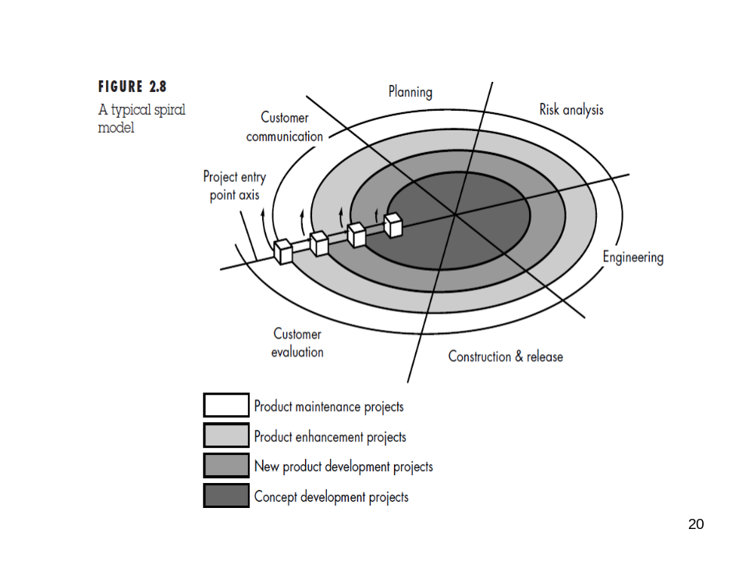
CONCURRENT DEVELOPMENT MODEL
- This is sometimes called concurrent engineering.This is represented schematically as a series of framework activities,software engineering actions and tasks,and their associated states.
- Fig provides schematic representation of one software engineering task within modelling activity.The activity modelling may in any one of these states at any given time.Similarly other activities can be represented in a similar manner.
- All activities exist concurrently but reside in different states.
- For ex.early in a project communication activity has completed its first iteration and exists in awaiting changes state.The modelling activity wchich existed in none state while initial communication was completed now makes a transition to underdevelopment state.If however customer indicates changes in requirements must be made,the modelling activity moves from under development to awaiting changes state
- The concurrent process model dfines a series of events that will trigger transition from state to state for each software engineering activities,actions and tasks.
- This model is applicable to all types of software development and provides correct pictre of accurate state of a project.

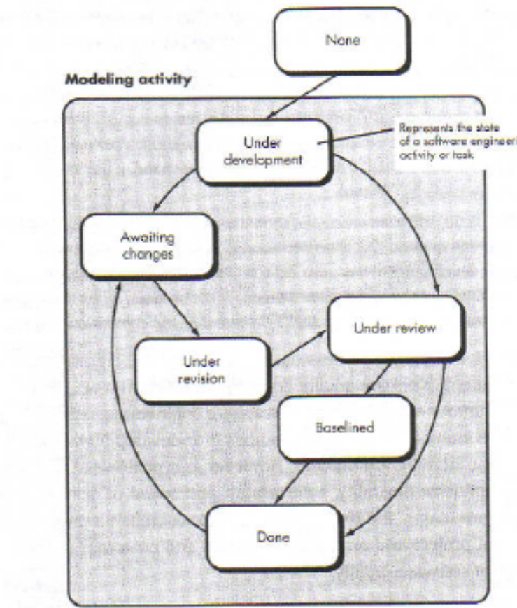

UNIFIED PROCESS MODEL
- This model is proposed by ivan jacobson,grady booch,rumbaugh
- This is a use-case driven,architecture-centric,iterative and incremental software process.
- This is a framework for object-oriented software engineering sing UML.
- The inception phase of Unified Process(UP) encompasses oth customer communication and planning activities.By colloborating with customer,business requirements for the software are identified.Fundamental business requirements are expressed through a set of preliminary use-cases that describes what features and functions are desired by major class of sers. Architecture at this point is nothing but outline of features and functions.Planning identifies resources,assesses major risks,defines a schedule.
- The elaboration phase encompasses communication,planning and modelling.Elaboration reines and expands preliminary use-cases
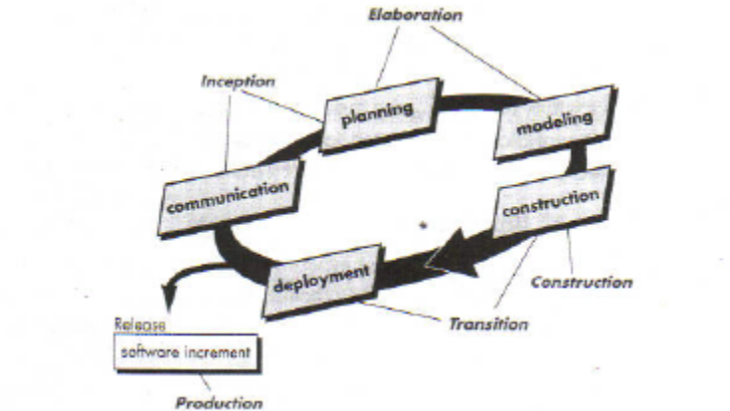
that were developed as part of inception phase.Expands architectural representation to include ive different views of software.the use-case model,the analysis model,the design model,the implementation model and the deployment model.Modification to the plan may be made at tis time
- Construction of UP is identical to constuction activity of generic process models.All necessary features and functions are implemented in souce code.As components are being developed unit test is bein conducted.
- The transition phase of UP encompasses later stages of construction activity and first part of deployment activity.Softwareis given to end-users for beta-testing.In addition software team creates installation procedres,user manuals etc.
- The prodction phase cooincides with deployment activity .During tis phase on-going use of software is monitored,and defect reports and request for changes are submitted and evaluated.
PERSONAL AND TEAM SOFTWARE PROCESS MODELS
The best software process is one that is close to people who will be doing the work.
Watts Humphrey argues that it is possible to create personal and/or team software process.Both require ardwaork,training&co-ordination butoth are acievable.
Personal s/w process
Every developer uses some process to build computer software.The process may be inefficient,effective or successful but a process does exist.
In order to change an ineffiecient process an individal mustmove through 4 phases,each require training and careful instrumentation.
Planning:Basedon requirements develop size and resource estimates.Metrics are recorded on worksheets.Finally development tasks are identified & a schedule is created.
High-Level Design: External specifications for each component to be constructed & developed & a component design is constructed.Prototypes are built when uncertainity exists.
High-Level Design Review:Formalverification methods are applied to uncover errors in design.Metrics are maintained for all important tasks and work result.
Development: Design is refined&reviewed.Code is generated,reviewed,compiled&tested.Metrics are maintained for all imp tasks.
Postmortem: Using measure & metrics collected,eectiveness of process is determined.
Team s/wprocess
Many projects are addressed by a team of practitioners
The goal of TSP is to ils a team that organises itself to produce high quality s/w.
TSP objectives
- Build self directed teams that plan & track their goals
- Show manager how to coach and motivate their teams.
- Accelerate software process improvement by making CMM level 5 normal and expected.
- Facilitate university teaching to pgrade team skills
TSP defines following framework activities project launch,high level design,implementation,integration,test & postmortem
TSP uses wide variety of scripts & standards that serve to guide team members in their work.Scripts define specific activities.
This is an exmple for project launch script.
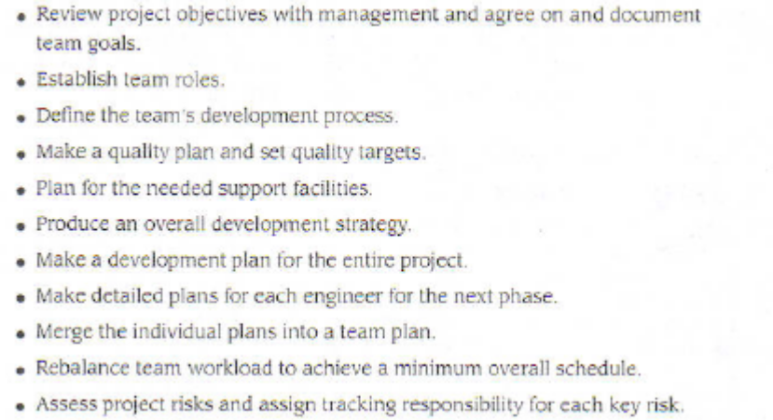

Software Requirements
Process of finding out, analysing and documenting the requirements is called requirements engineering
Types of requirement
User requirements
  - Statements in natural language plus diagrams of the services the system provides and its operational constraints. Written for customers.
System requirements
  - A structured document setting out detailed descriptions of the system’s functions, services and operational constraints. Defines what should be implemented so may be part of a contract between client and contractor.
Functional and non-functional requirements
Functional requirements
  - Statements of services the system should provide, how the system should react to particular inputs and how the system should behave in particular situations.
Non-functional requirements
  - Constraints on the services or functions offered by the system such as timing constraints, constraints on the development process, standards, etc.
Domain requirements
Requirements that come from the application domain of the system and that reflect characteristics of that domain
Functional requirements
- Describe functionality or system services.
- Depend on the type of software, expected users and the type of system where the software is used.
- Functional user requirements may be high-level statements of what the system should do but functional system requirements should describe the system services in detail.

The LIBSYS system
- A library system that provides a single interface to a number of databases of articles in different libraries.
- Users can search for, download and print these articles for personal study.
Examples of functional requirements
- The user shall be able to search either all of the initial set of databases or select a subset from it.
- The system shall provide appropriate viewers for the user to read documents in the document store.
- Every order shall be allocated a unique identifier (ORDER_ID) which the user shall be able to copy to the account’s permanent storage area.
In principle, requirements should be both complete and consistent.
Complete
They should include descriptions of all facilities required.
Consistent
There should be no conflicts or contradictions in the descriptions of the system facilities.
In practice, it is impossible to produce a complete and consistent requirements document.
Non-functional requirements
These define system properties and constraints e.g. reliability, response time and storage requirements. Constraints are I/O device capability, system representations, etc.
Non-functional requirements may be more critical than functional requirements. If these are not met, the system is useless.
Non-functional classifications
Product requirements These requirements specify product behaviour.Examples include performance requirements on how fast the system must execute and how much memory it requires; reliability requirements that set out the acceptable failure rate; portability requirements; and usability requirements.

2. Organisational requirements these requirements are derived from policies and procedures in the customer s and developer s organization. Examples include process standards that must be used; implementation requirements such as the programming language or design method used; and delivery requirements that specify when the product and: Its documentation are to be delivered.
3. External requirements This broad heading covers all requirements that are derived from factors external to the system and its development process. These may include interoperability requirements that define how the system interacts with systems in other organizations: legislative requirements that must be followed to ensure that the system operates within the law; and ethical requirements. Ethical requirements are requirements placed on a system to ensure that it will be acceptable to its users and the general public.

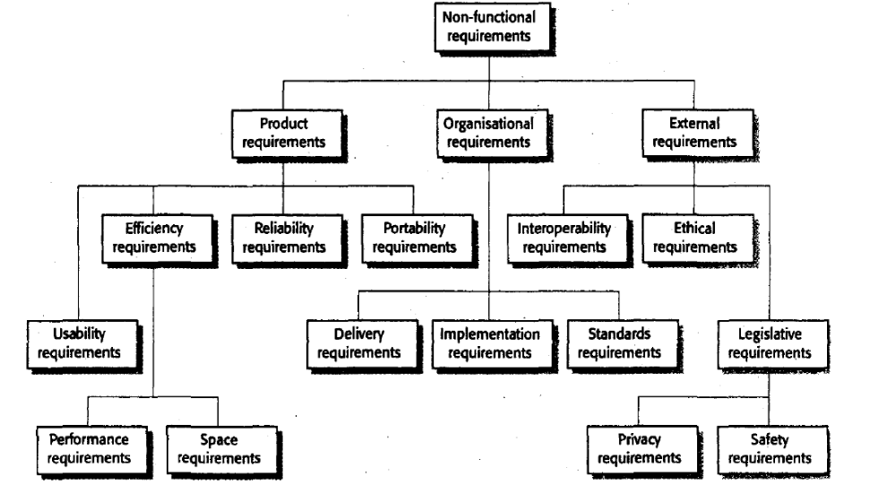

Non-functional requirements examples
Product requirement
The user interface for LIBSYS shall be implemented as simple HTML without frames or Java applets.
Organisational requirement
The system development process and deliverable documents shall conform to the process and deliverables defined in XYZCo-SP-STAN-95.
External requirement
The system shall not disclose any personal information about customers apart from their name and reference number to the operators of the system.

A common problem with non-functional requirements is that they can be difficult to verify. Users or customers often state these requirements as general goals These vague goals cause problems for system developers as they leave scope for interpretation and subsequent dispute once the system is delivered. As an illustration of this problem, consider below This shows a system goal relating to the usability of a traffic control system and is typical of how a user might express usability requirements. I have rewritten it to show how the goal can be expressed
as a 'testable' non-functional requirement.

Goal
  - A general intention of the user such as ease of use.
Verifiable non-functional requirement
  - A statement using some measure that can be objectively tested.
A system goal
  - The system should be easy to use by experienced controllers and should be organised in such a way that user errors are minimised.
A verifiable non-functional requirement
  - Experienced controllers shall be able to use all the system functions after a total of two hours training. After this training, the average number of errors made by experienced users shall not exceed two per day.

Whenever possible we should write non-functional requirements quantitatively so that they can be objectively tested.

You can measure these characteristics when the system is being tested to check whether or not the system has met its non-functional requirements.

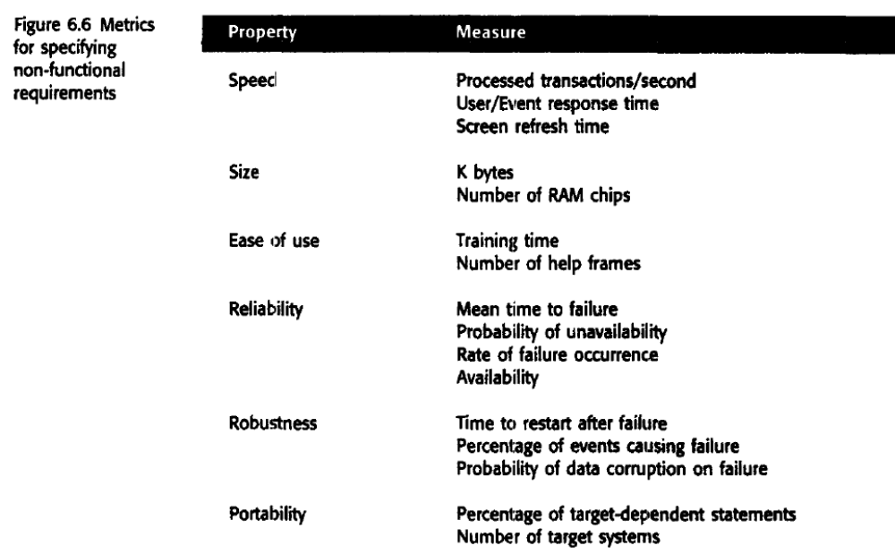

In practice, however, customers for a system may find it practically impossible to translate their goals into quantitative requirements. For some goals, such as maintainability, there are no metrics that can be used.

Domain requirements

Domain requirements are derived from the application domain of the system rather than from the specific needs of system users.
Domain requirements are important because they often reflect fundamentals of the application domain. If these requirements are not satisfied, it may be impossible to make the system work satisfactorily.
Library system domain requirements
- There shall be a standard user interface to all databases which shall be based on the Z39.50 standard.

- Because of copyright restrictions, some documents must be deleted immediately on arrival. Depending on the user’s requirements, these documents will either be printed locally on the system server for manually forwarding to the user or routed to a network printer.

The first requirement is a design constraint. It specifies that the user interface to the database must be implemented according to a specific library standard. The developers
therefore have to find out about that standard before starting the interface design. The second requirement has been introduced because of copyright laws that apply to material used in libraries. It specifies that the system must include an automatic delete-on-print facility for some classes of document. This means that users of the library system cannot have their own electronic copy of the document.

The deceleration of the train shall be computed as:
  - D_{train} = D_{control} + D_{gradient}
where D_{gradient} is 9.81ms² * compensated gradient/alpha and where the values of 9.81ms² /alpha are known for different types of train.

This system automatically stops a train if it goes through a red signal. This requirement states how the train deceleration is computed by the system.It uses domain-specific terminology. To understand it, you need some understanding of the operation of railway systems and train characteristics.

Domain requirements problems

Requirements are expressed in the language of the application domain;
This is often not understood by software engineers developing the system.
Domain experts may leave information out of a requirement simply because it is so obvious to them. However, it may not be obvious to the developers of the system,and they may therefore implement the requirement in the wrong way.

USER REQUIREMENTS
Should describe functional and non-functional requirements in such a way that they are understandable by system users who don’t have detailed technical knowledge.
User requirements are defined using natural language, tables and diagrams as these can be understood by all users.

However various problems can arise when requirements are written in natural language sentences in a text document:

Lack of clarity
It is sometimes difficult to use language in a precise and unambiguous way without making the document wordy and difficult to read.
Requirements confusion
Functional and non-functional requirements tend to be mixed-up.
Requirements amalgamation
Several different requirements may be expressed together as a single requirement.

EXAMPLE

Discover ambiguities and omissions for part of a ticket-issuing system

- An automated ticket-issuing system sells rail tickets. Users select their destination and input a credit card and a personal identification number. The rail ticket is issued and their credit card account charged. When the user presses the start button, a menu display of potential destinations is activated, along with a message to the user to select a destination. Once a destination has been selected, users are requested to input a personal identification number When the credit transaction has been validated, the ticket is issued.

Sol:
Can a customer buy several tickets for the same destination together or must they be bought one at a time?
b) Can customers cancel a request if a mistake has been made?
c) How should the system respond if an invalid card is input?
d) What happens if customers try to put their card in before selecting a destination (as they would in ATM machines)?
e) Must the user press the start button again if they wish to buy another ticket to a different destination?

To minimise misunderstandings when writing user requirements, following guidelines are recommended.

- Invent a standard format and use it for all requirements.
- Use language in a consistent way. Use shall for mandatory requirements, should for desirable requirements.
- Use text highlighting to identify key parts of the requirement.
- Avoid the use of computer jargon.
EXAMPLE
  - Using the technique suggested here, where natural language is presented in a standard way, write plausible user requirements for the following function
The cash dispensing function in a bank ATM.
SOL:The user shall enter their bank card in the slot provided. Following the appropriate prompts for a cash withdrawal, the user shall enter the requested amount. If the amount requested is not greater than the amount in the account, cash shall be dispensed, and the card shall be returned.

System requirements

System requirements are expanded versions of the user requirements that are used by software engineers as the starting point for the system design. They add detail and explain how the user requirements should be provided by the system

Ideally, the system requirements should simply describe the external behavior of the system and its operational constraints. They should not be concerned with how the system should be designed or implemented

Natural language is often used to write system requirements specifications as well as user requirements. However, because system requirements are more detailed than user requirements, natural language specifications can be confusing and hard to understand:

- Natural language understanding relies on the specification readers and writers using the same words for the same concept. This leads to misunderstandings because of the ambiguity of natural language ex shoes must be worn and dogs must be carried.

- A natural language requirements specification is overflexible. You can say the same thing in completely different ways. It is up to the reader to find out when requirements are the same and when they are distinct

- There is no easy way to modularise natural language requirements. It may be difficult to fmd all related requirements

Because of these problems, requirements specifications written in natural language are prone to misunderstandings. These are often not discovered until later phases of the software process and may then be very expensive to resolve.

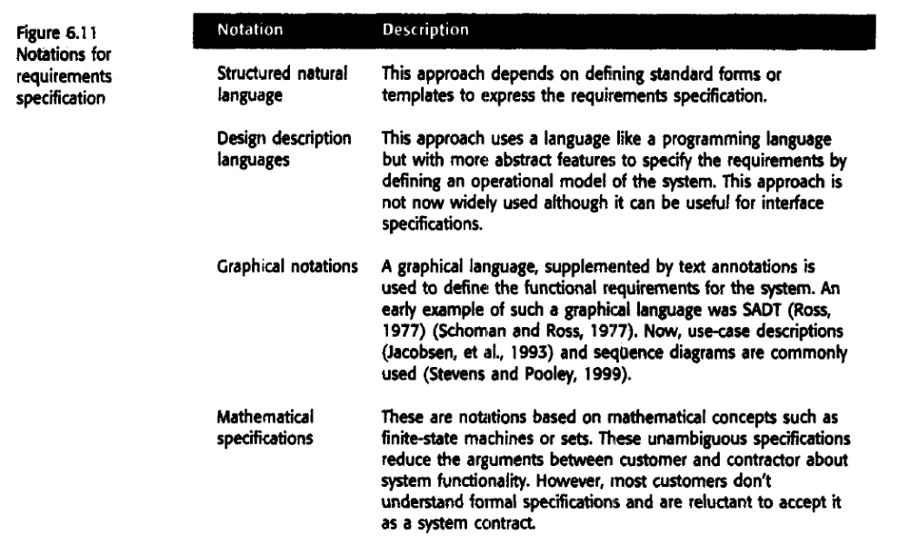

Structured language specifications

- The freedom of the requirements writer is limited by a predefined template for requirements.
- All requirements are written in a standard way.
- The terminology used in the description may be limited.

The advantage is that the most of the expressiveness of natural language is maintained but a degree of uniformity is imposed on the specification

When a standard fonn is used for specifying functional requirements, the following
information should be included:

- Definition of the function or entity.
- Description of inputs and where they come from.
- Description of outputs and where they go to.
- Indication of other entities required(requires part)
- Description of the action to be taken.
- Pre and post conditions (if appropriate).
- The side effects (if any) of the function.

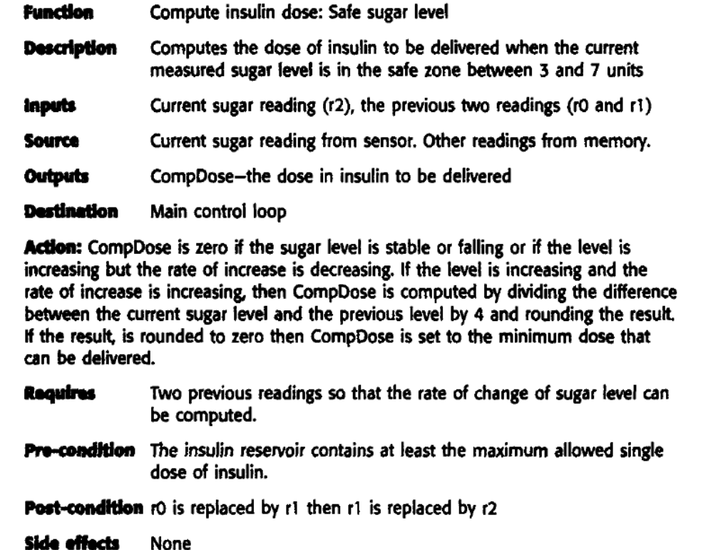

Using formatted specifications removes some of the problems of natural language specification. Variability in the specification is reduced and requirements are organised more effectively. However, it is difficult to write requirements in an unambiguous ay, particularly when complex computations are required.

To address this problem, you can add extra information to natural language requirements
using tables or graphical models of the system.

Tables are particularly useful when there are a number of possible alternative
situations and you need to describe the actions to be taken for each of these.

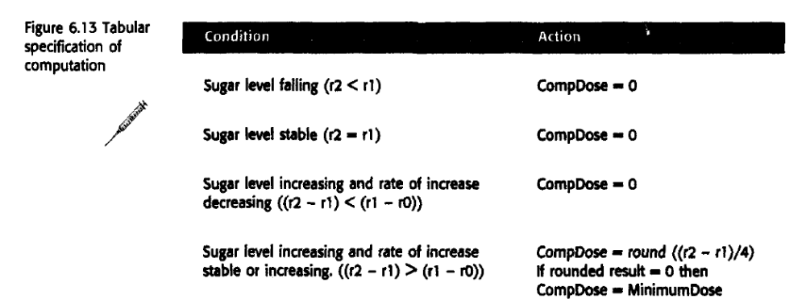

Graphical models are most useful when you need to show how state changes or where you need to describe a sequence of actions.

Sequence diagrams

- These show the sequence of events that take place during some user interaction with a system.
- You read them from top to bottom to see the order of the actions that take place.
- Cash withdrawal from an ATM
  - Validate card;
  - Handle request;
  - Complete transaction.

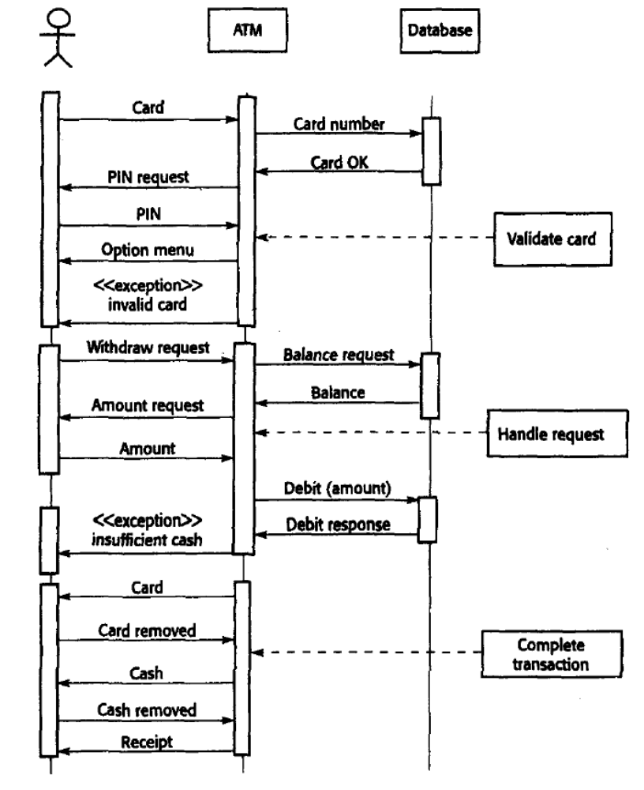

INTERFACE SPECIFICATIONS

Almost all software systems must operate with existing systems that have already been implemented and installed in an environment. If the new system and the existing systems must work together, the: interfaces of existing systems have to be precisely specified.

There are three types of interface: that may have to be defined:

1. Procedural interfaces where existing programs or sub-systems offer a range of
services that are accessed by calling interface procedures. These interfaces are
sometimes called Application Programming Interfaces (APls).

2. Data structures that are passed from one sub-system to another. Graphical data
models (described in Chapter 8) are the best notations for this type of description.

3.Representations of data (such as the ordering of bits) that have been established
for an existing sub-system. the best way to describe these is probably to use a diagram of the structure with annotations explaining the function of each group of bits.

Figure 6.15 is an example of a procedural interface definition defined in Java.In this case, the interface is the procedural interface offered by a print server. This manages a queue of requests to print files on different printers. Users may examine the queue associated with a printer and may remove their print jobs from that queue. They may also switch jobs from one printer to another.

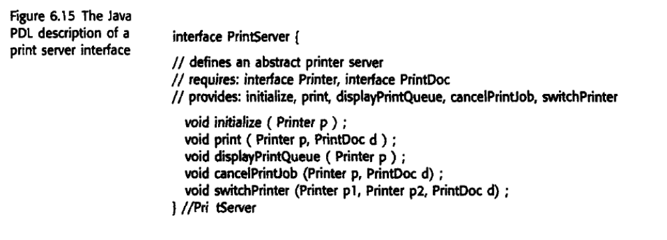
The software requirements document

The software requirements document (sometimes called the software requirements specification or SRS) is the official statement of what the system developers should implement. It should include both the user requirements for a system and a detailed specification of the system requirements.

In some cases, the user and system requirements may be integrated into a single description. In other cases, the user requirements are defined in an introduction to the system requirements specification.If there are a large number of requirements, the detailed system requirements
may be presented in a separate document.

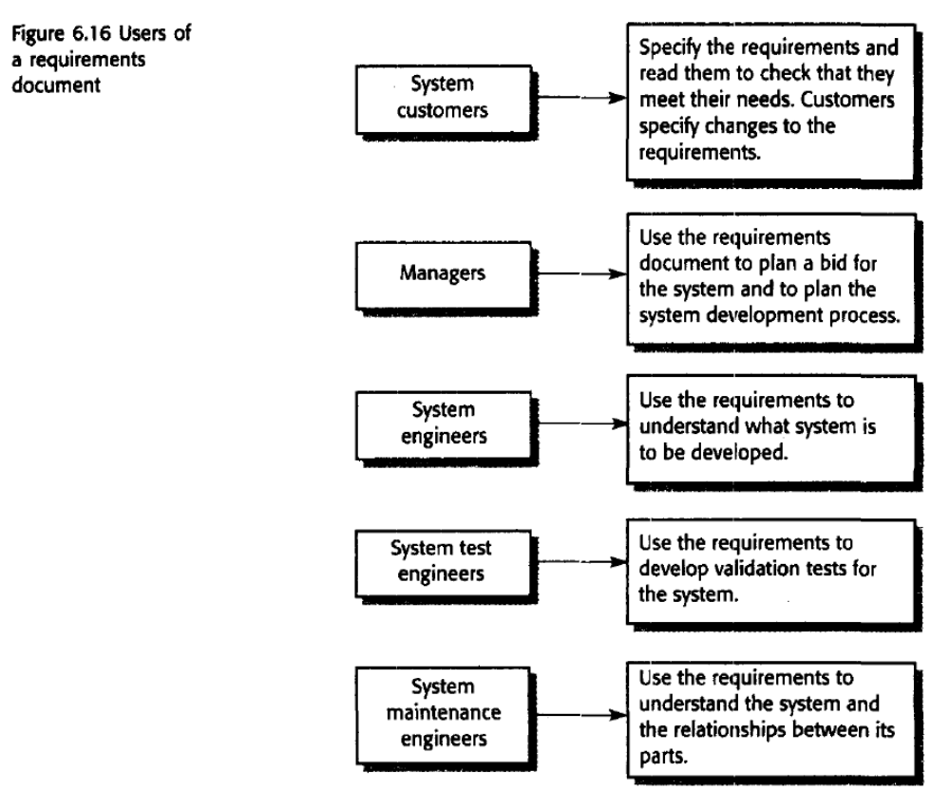

A number of large organisations, such as the US Department of Defense and the
IEEE, have defined standards for requirements documents.

IEEE standard suggests the following structure for requiremems documents:

I. Introduction
1.1 Purpose of the requiremt:nts document
1.2 Scope of the product
1.3 Definitions, acronyms and abbreviations
1.4 References
1.5 Overview of the remainder of the document

2. General description
2.1 Product perspective
2.2 Product functions
2.3 User characteristics
2.4 General constraints
2.5 Assumptions and dependencies
3. Specific requirements cover functional, non··functional and interface requirements. The requirements may document external interfaces, describe system functionality and performance, specify logical database requirements, design constraints, emergent system properties and quality characteristics.
4. Appendices
5. Index

Although the IEEE standard is not ideal, it contains a great deal of good advice on how to write requirements and how to avoid problems. It is too general to be an organizational standard in its own right.

Figure 6.17 illustrates a possible organization for a requirements document that is based on the IEEE standard. However, the below fig have extended this to include information about predicted system evolution. This was first proposed by Heninge

The information that is included in a requirements document must depend on the type of software being developed and the approach to development that is used. If an evolutionary approach is adopted for a software product (say), the requirements document will leave out many of detailed chapters suggested above. The focus will be on defining the user requirements and high-level, non-functional system requirements. In this case, the designers and programmers use their judgment to decide how to meet the outline user requirements for the system

For long documents, it is particularly important to include a comprehensive table of contents and document index so that readers can find the information that they need.

